Local London Data Warehouse User Guide

Welcome to the Local London Data Warehouse user guide.
This document explains how to use the warehouse, and how you can best explore the data we offer.
Before you begin exploring, we recommend opening the dashboard in
full-screen mode by pressing the diagonal arrows on the bottom right.

Navigation
You can return to the home page at any time by clicking on our Local London logo, or return to your selected data dashboard selection using the button on the top left of each data visual page.
Our visuals have been divided into categories to help you find relevant data based on your area of interest.
The Data Warehouse will open on the home page (below left) where you can select the category you wish to explore.
New categories may be added later as the sub-region evolves and focusses on new topics.
By clicking on your chosen section, you can view the data dashboard (below right) for your chosen area, which shows all the relevant, available information we have to offer.
Each data dashboard shows the source, and latest update of each dataset we have available.
Use the coloured buttons to jump to the visuals for that dataset, where you can interact with them.
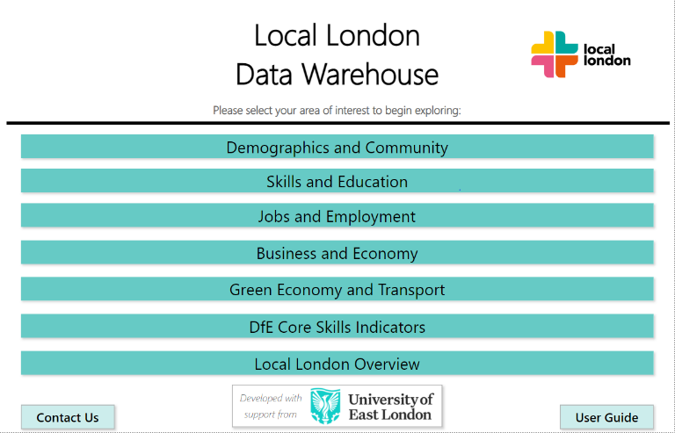
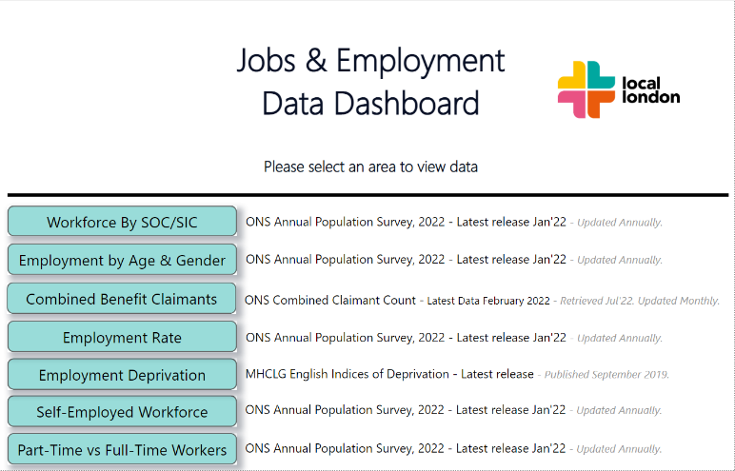
Warehouse Homepage Data Dashboard

Using the Data Warehouse – How to get the data you need from our visuals

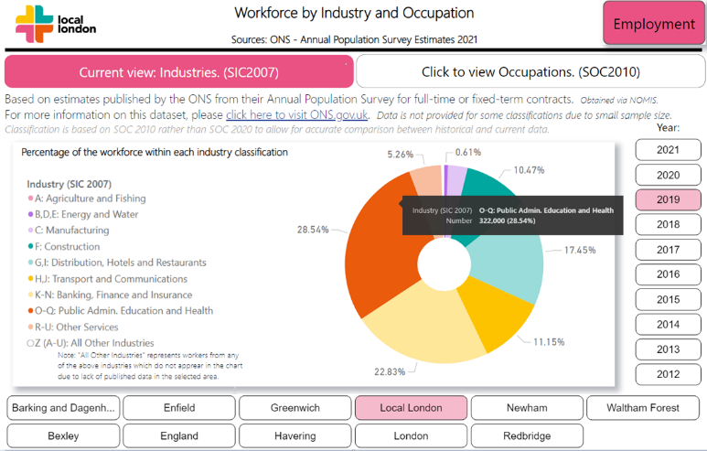
Some data has an alternative source, analysis, or presentation style, accessed by these buttons.
This is the data description, key notes, and link to source.
Each data page has selection criteria which can be used to view the data relevant to you. Some pages allow you to select multiple values in the same criteria so they can be compared (e.g. comparing your borough with figures for Local London, and London as a whole).
On some pages, you can hover over the charts to view data details such as values, when percentages are shown.
All data within the Local London Data Warehouse is open-source, publicly accessible data. The visuals within the chart are free for you to use to support your own work by taking a screenshot, print screen or the snipping tool.
If you have any questions or queries about the Data Warehouse, please contact us using the homepage button.

